Welcome
Song 1 – Come Praise and Glorify
Song 2 – The Lord is my Salvation
Declaration – Psalm 31:1-5
Lord's Supper
Offering
NT Bible Reading – tbc
Prayer
Announcements
Kids' Song – Tell Them

Song 3 –Hymn of the Saviour
OT Bible Reading – Malachi 3:6-12
Sermon
Closing Song – His Glory and My Good
Mutual Upbuilding

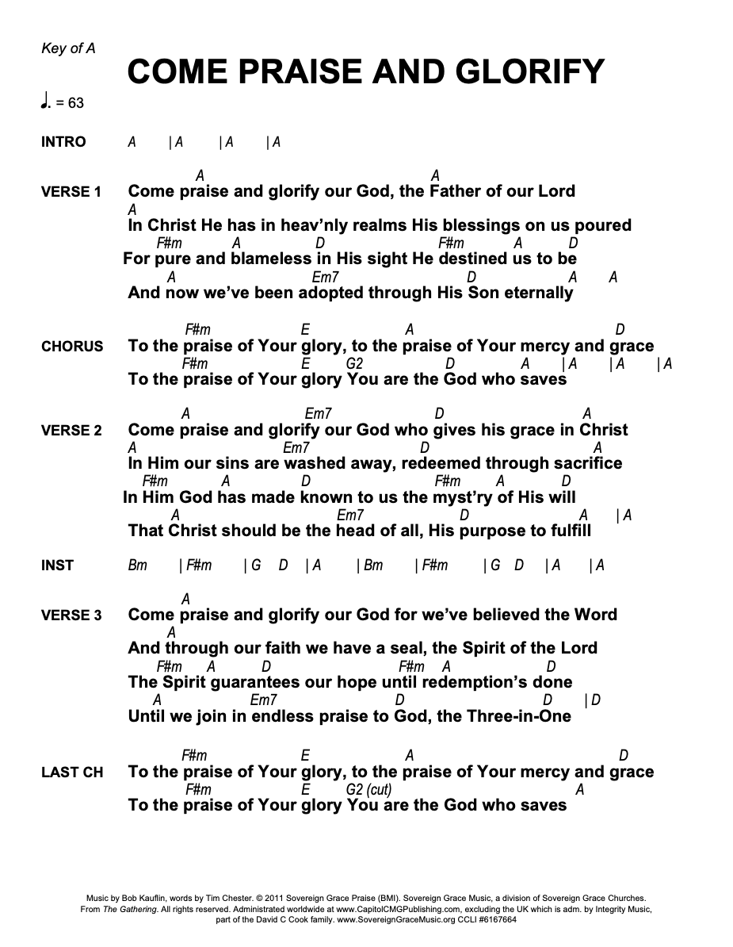
The Lord is My Salvation (G)

[Intro]
G C G C

[Verse 1]
Em C Dsus D
The grace of God has reached for me
Em C Dsus D
and pulled me from the raging sea;
C/E D/F# G G/B C
and I am safe on this solid ground,
Am7 D C/G
the Lord is my salvation.

[Verse 2]
Em C Dsus D
I will not fear when darkness falls,
Em C
His strength will help me scale these
Dsus D
walls;
C/E D/F# G G/B C
I'll see the dawn of the rising sun,
Am7 D C/G G/D
the Lord is my salvation.

[Chorus]
D C G/B
Who is like the Lord our God,
D C G/B
strong to save, faithful in love?
Em D/F# G G/B C
my debt is paid, and the victory won;
Am7 D G D G D
the Lord is my salvation.

[Verse 3]
Em C Dsus D
My hope is hidden in the Lord,
Em C Dsus D
He flowers each promise of His word;
C/E D/F# G G/B C
when winter fades, I know spring will come,
Am7 D C/G G/D
the Lord is my salvation.

[Verse 4]
Em C Dsus D
In times of waiting, times of need,
Em C Dsus D
when I know loss, when I am weak,
C/E D/F# G G/B C
I know His grace will renew these days;
Am7 D C/G G/D
the Lord is my salvation.

CHORUS

G no intro

[Verse 5]
Em C Dsus D
And when I reach my final day,
Em C Dsus D
He will not leave me in the grave;
C/E D/F# G G/B C
but I will rise, He will call me home.
Am7 D C/G G/D
The Lord is my salvation.

CHORUS

[Bridge] x2
C G/B D/F# Em
Glory be to God the Father,
C G/B D
glory be to God the Son,
C G/B Bm Em
glory be to God the Spirit;
Am7 Dsus Gsus
the Lord is our salvation.

CHORUS

[Bridge 2nd time ending]
Am7 Dsus Em D C G/B
the Lord is our salvation.
Am7 D Em D C G/B
The Lord is our salvation,
Am7 D G C G
the Lord is our salvation.

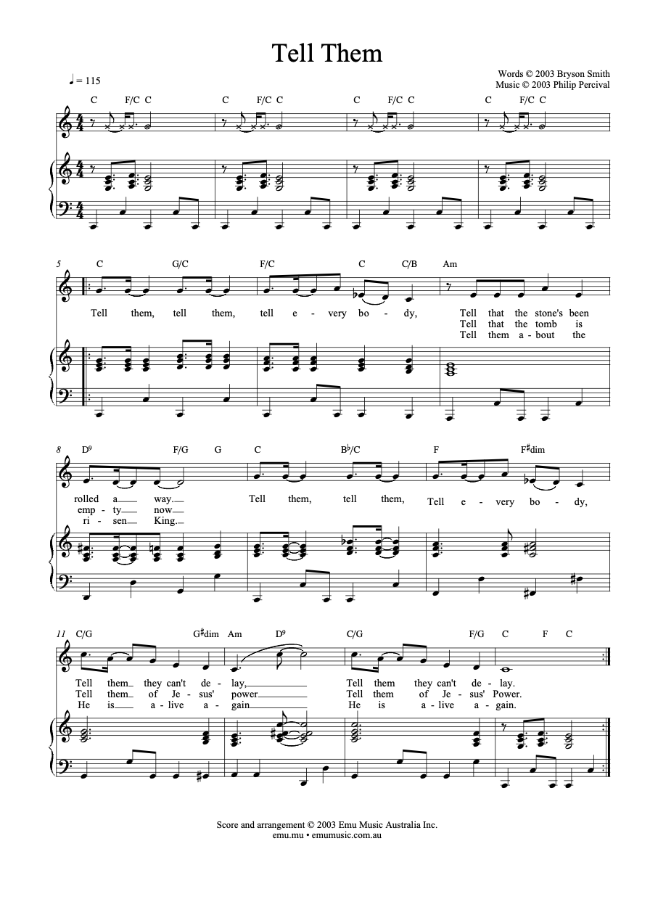
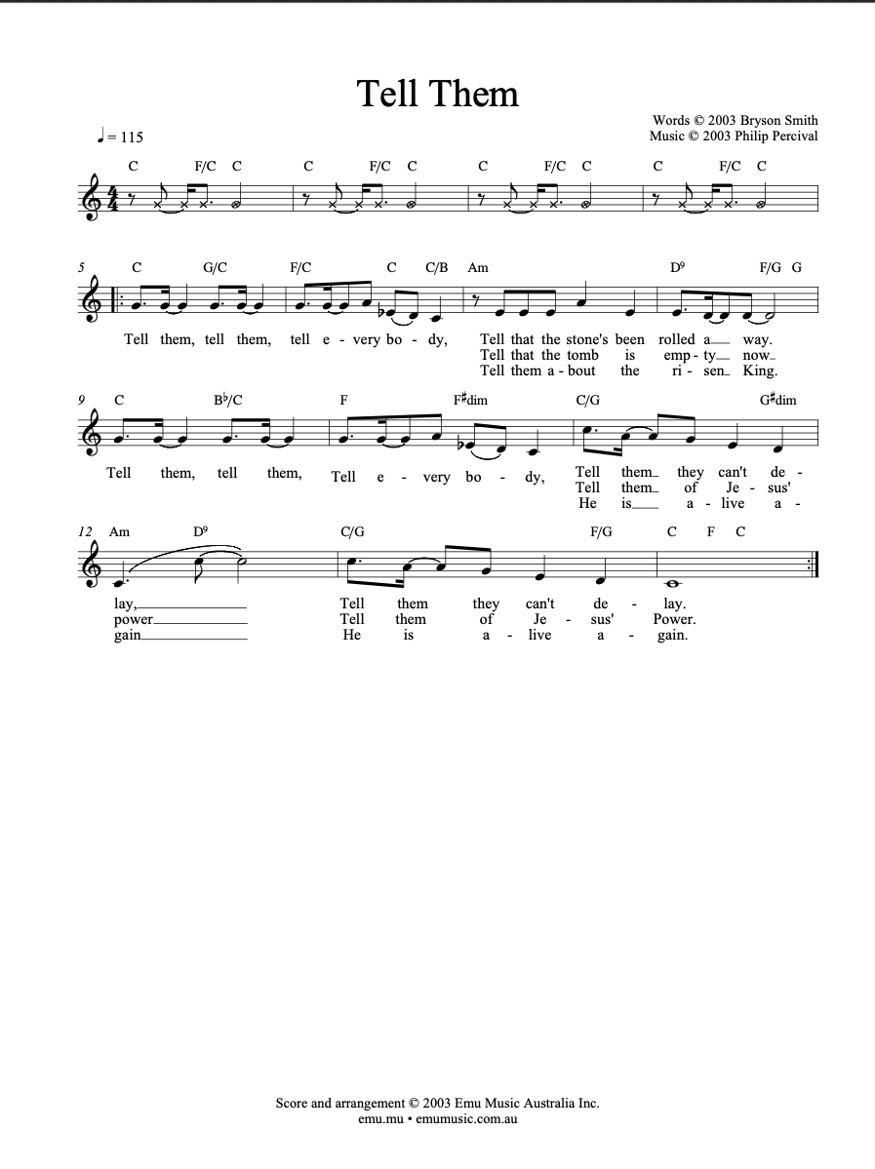
Hymn of the Saviour: Emu Music (C)
Keys intro
[Intro]
F Am C2 C2

[Verse 1]
Am F
From the chaos of darkness
C G
Your word shaped the earth
Am F C
In your image a people made
Am F
But we traded perfection
C G
The truth for a lie
Am F C
And your glory was veiled in shame

[Verse 2]
F C
But a promise made
G Am
A blessing you gave
F C G
To a people of your name
F C
For this broken world
Em Am
A saviour foretold
F G
To bear all our grief and pain

F Am C C x2
[Verse 3] Build Up
Am F
When the heavenly saviour
C G
Descended his throne
Am F C
All my sin on his shoulders laid
Am F
And to win our redemption
C G
He suffered and died
Am F C
For the sake of my guilt and shame

[Verse 4]
F C
Oh the price he paid
G Am
In taking my place
F C G
so that death was overcome
F C
For the king of love
Em Am
Burst forth from the grave
F G
Proclaiming the victory won

F Am C C x2

[Verse 5] (Soft)
Am F
At the end of the ages
C G
The world passed away
Am F C
I will gaze on my saviour's face
Am F
When my heart is perfected
C G
Free from my sin
Am F C (build)
I will rest in your glorious grace
Build to top
[Verse 6]
F C
For the song we raise
G Am
The works of our hands
F C G
Are in service of the king
F C
When a thousand tounges
Em Am
Cry "Glory to God"
F G F
Forever his praise we'll sing
F C
For the song we raise
G Am
The works of our hands
F C G
Are in service of the king
F C
When a thousand tounges
Em Am
Cry "Glory to God"
F G Am
Forever his praise we'll sing
F G F
Forever his praise we'll sing
Am C C
F Am C End

His Glory and my good
Intro
Asus2 E B C#m7 x2

Verse 1
Asus2 E
I have seen my Father’s glory
B C#m7
Revealed in Jesus Christ
Asus2 E
And the more that I behold Him
B C#m7
The more He satisfies
A E
When I gaze upon His beauty
B C#m7
When I see Him as I should
Asus2 E/G#
Then my eyes are lifted upward
B Asus2 E B C#m7
For His glory and my good

Verse 2:
Asus2 E
There is hope in every trial
B C#m7
For I can trust the Lord
Asus2 E
He will turn my heart towards Him
B C#m7
And help me bear the thorn
A E
So in faith I follow Jesus
B C#m7
On the road not understood
Asus2 E/G#
For I know that He is working
B E5 A4
For His glory and my good

Chorus 1
E
To our God be the glory
A E
To our God be praise
C#m7 B
He alone, the name above all names
E/G# A C#m7
I will boast ever only in the Lord my God
A B Asus2 E B C#m7
For I know His glory is my good

Verse 3:
Asus2 E
See the open arms of Jesus
B C#m7
Upon the cross that day
Asus2 E
What they understood as weakness
B C#m7
Deserves my every praise
A E
For the charge that was against me
B C#m7
It was nailed into the wood
Asus2 E/G#
Yes I know that He has saved me
B E
For His glory and my good
CHORUS
Instrumental: A E/G# C#m7 B x4
Verse 4:
Asus2 E
Would I gladly be made nothing
B C#m7
That Christ would be made more
Asus2 E
Would I seek the only kingdom
B C#m7
That far outweighs them all
A E
I will stand before my Father
B C#m7
Where the faithful saints have stood
Asus2 E/G#
And with joy my heart shall praise Him
B E
For His glory and my good

CHORUS
A B C#m7
For I know His glory is my good
A B
For I know His glory is my good

Ending: Asus2 E B E

